Name: Ramyashree R Batch: B7

Task: How to search all the patterns in a closed file starting with same letters?

Date: 21-09-2023

**How to delete a link?**

To delete a symbolic link (also known as a symlink) in Linux, you can use the rm command followed by the path to the symlink. Here's the basic syntax:

Syntax: rm /path/to/symlink

Ex: if you have a symlink called mylink in your home directory, you can delete it like this:

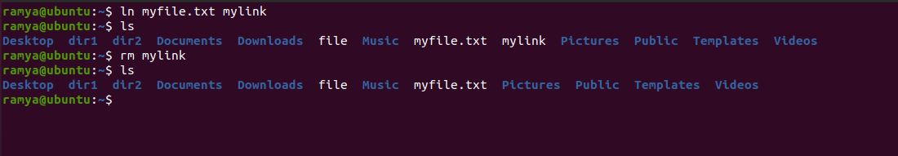

stat Command: The stat command provides detailed information about a file, including the number of hard links.

Use the following syntax:

Stat filename

**ln Command:** When creating a hard link using the ln command, you can specify options like -P or -L to control how the link is resolved. These options are not flags for the hard link itself but affect how the link behaves:

**-P:** Create hard links by dereferencing symbolic links. This means the hard link will point to the actual file the symbolic link refers to.

**-L:** Create hard links by following symbolic links. This means the hard link will point to the symbolic link itself, not the target it points to.

Example: ln -P source_file link_name

The **du command** in Linux is used to estimate the disk usage of files and directories. It's a versatile tool that can provide various insights into storage consumption. Here are some commonly used flags with the du command:

**-s, --summarize**: This flag displays only the total disk usage of the specified directory, without showing the sizes of individual subdirectories.

du -sh /path/to/directory



**-c, --total:** Similar to -s, this flag displays the total disk usage, but it also includes a summary line at the end that shows the grand total for all directories and files processed.

du -c /path/to/directory

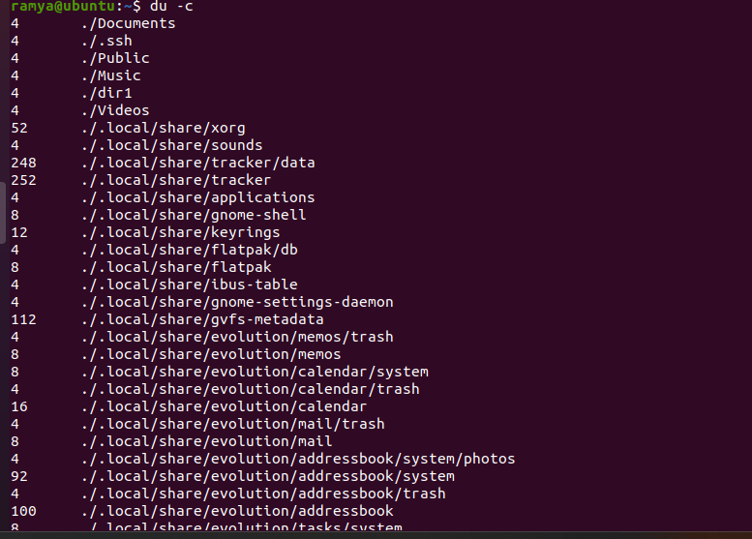

**-a, --all:** This flag displays the sizes of both files and directories within the specified directory, including hidden files (those starting with a dot).

du -ah /path/to/directory

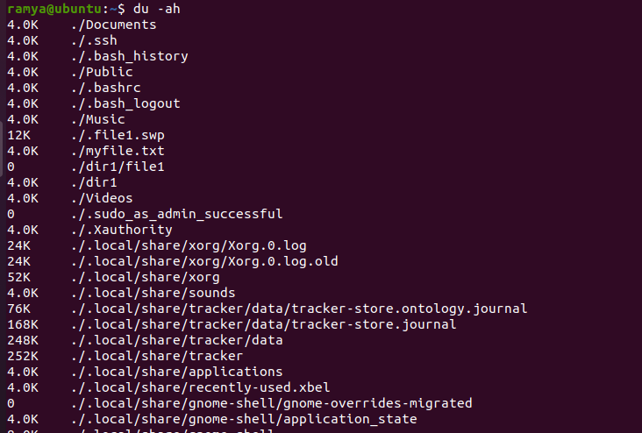

**--exclude=PATTERN:** You can use this flag to exclude files or directories from the disk usage calculation based on a pattern. For example, to exclude all ".log" files:

du --exclude='*.log' /path/to/directory

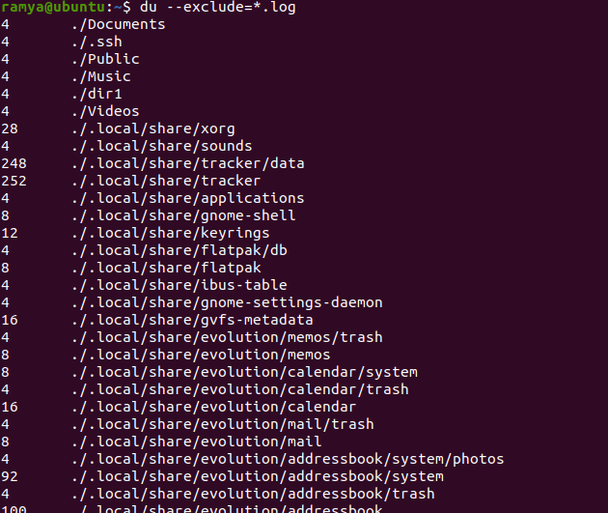

**--exclude-from=FILE:** Similar to --exclude, this flag allows you to specify exclusion patterns from a file. Each line in the file represents a pattern to be excluded.

du --exclude-from=exclude_list.txt /path/to/directory

**--time:** This flag shows the time taken for the du command to calculate disk usage.

du --time /path/to/directory

The df command in Linux is used to display disk space usage for file systems. It provides information about the total disk space, used space, available space, and file system types. Here are some commonly used flags with the df command:

-T, --print-type: This flag displays the file system type for each mounted file system in the output.

df -T

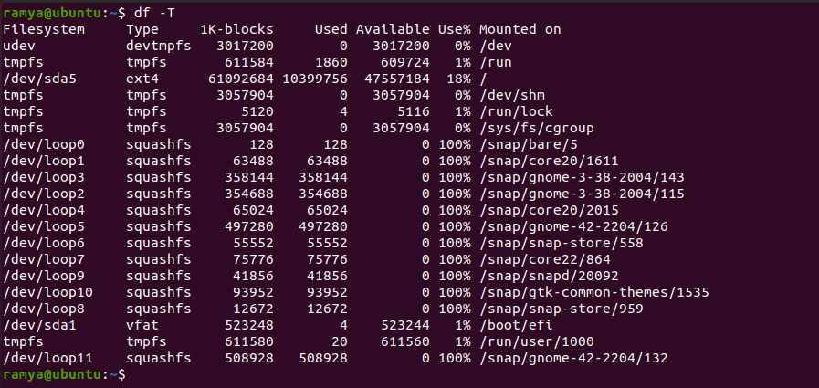

-t, --type=TYPE: Use this flag to filter and display information about file systems of a specific type. Replace TYPE with the file system type you want to filter. For example, to display only ext4 file systems:

df -t ext4



-i, --inodes: This flag displays information about the number of used and available inodes (data structures that represent files and directories) in addition to the disk space usage.

df -i

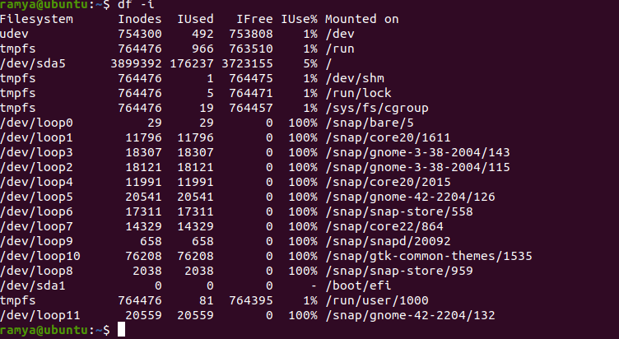

-b, --bytes: Displays memory sizes in bytes, which is the default behavior of the free command.

free -b

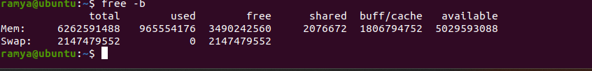

-s, --seconds=N: This flag updates the displayed information every N seconds. This is useful for continuous monitoring of memory usage.

free -s 5 # Update every 5 seconds

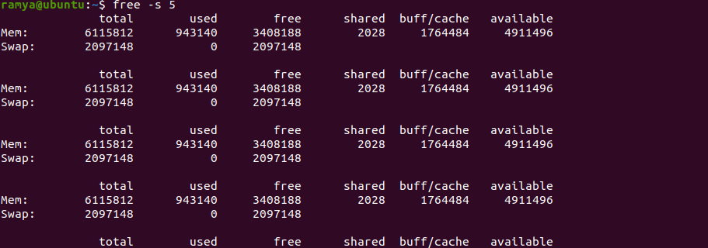

-w: This flag displays additional information about swap space. It shows columns for swap used, swap free, and total swap.

free -w



Who

-a, --all: This flag displays information about all users, including system users and users with non-terminal sessions.

who -a

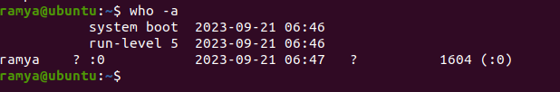

-b, --boot: Shows the time of the last system boot.

who -b

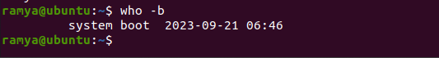

-d, --dead: Display information about dead processes (those that have been terminated but their entries have not been removed).

who -d

-H, --heading: Displays a header line at the beginning of the output to label the columns.

who -H

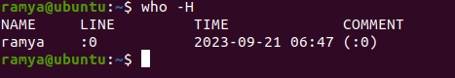

-l, --login: Displays detailed information, including the username, terminal, date, and time of login.

who -l

-m, --me: Shows information about the current user only.

who -m

-q, --count: Displays the total number of users currently logged in.

who -q

-s, --short: Provides a shorter output format with just the username and terminal.

who -s

-T, --time: Displays the last change of system clock.

who -T

-u, --users: Shows the usernames of users currently logged in.

who -u

-w, --message: Shows user messages. This displays the message and sender for users who have sent messages to others using the write command.

who -w

--ips: Displays the IP addresses from which users are logged in. Useful for remote logins.

who --ips



1. Three flags/arguments of today’s commands?

Today (20/09/23/) we learnt the following commands:

* Wc – word count
* Cp – copy
* Grep

Wc flags

* -m - it will print the characters count
* -w - it will print the words count
* -l - it will print the new lines count

Cp flags

* -a - it will archive the file
* -b - it will back up the file but doesn’t accept an argument
* --backup - it will create backup of each destination file
* -i – (Interactive option) It warns the user before it overwriting the destination file.
* -R – recursively – behaves recursively to copy an entire directory structure.

Grep flags

* -v - it will output the version number and exit.
* --help - it will output a usage message and exit.
* -w - it will select only those lines containing matches that from whole word.

***